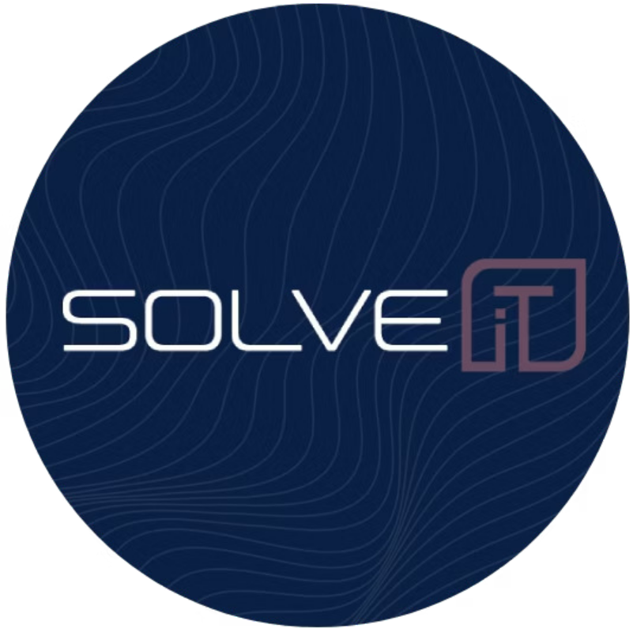

# Transform Operations. Automate Growth.

Powered by AI.

SolvIt AI delivers end-to-end intelligent automation solutions tailored for modern enterprises.

Explore Our AI Solutions ³

# Why Choose SolvIt AI?

Trusted by Fortune 500



ISO 27001 F SOC 2 Type II Compliant



234 Week Rapid Deployment



Multilingual F Emotion-Aware AI



24/7 Enterprise Support



# About SolvIt AI

## Our Vision

To become the leading AI automation partner in the MENA region, powering a future where every business process is intelligent, seamless, and sustainable 4aligned with the transformative goals of 2030.

## Our Mission

Enable enterprises to transform operations through secure, scalable, and human-centric AI automations that deliver measurable efficiency, growth, and innovation.



Faster Time-to-Value

2–4 week deployments for initial modules



Human-Like Interfaces

Multi-channel conversational AI that feels natural



Continuous Learning

Using retrieval-augmented generation (RAG) and feedback loops



Secure F Compliant

Privacy-aware architecture built for enterprise trust



Flexible Consumption

SaaS, API, private cloud, or on-premises deployment

[](https://gamma.app/?utm_source=made-with-gamma)Our commitment aligns with 2030 strategic frameworks to leverage AI for sustainable growth, operational excellence, and inclusive digital transformation.

# AI Automation Service Suites

Modular, scalable AI solutions designed to optimize enterprise operations.



Customer Support F Call Center AI

Voicebot

Live Agent Assist Call Summarization

**Use Case:** Retail 4 Handles 80% of returns & tracking queries autonomously.



Business Process F Backoffice AI

Document Processing Email Automation Meeting Summaries

**Use Case:** Legal Firms 4 Auto-extract clauses from 1,000+ contracts monthly.



Sales F Marketing AI

Lead Scoring AI CRM

Personalized Campaigns

**Use Case:** SaaS 4 Increases qualified leads by 40% through AI enrichment.



Knowledge F Internal AI Assistants

Enterprise Q&A Bot Slack/Teams Assistant

Auto-Updating Knowledge Base

**Use Case:** IT Teams 4 Cuts onboarding time by 60%.



HR F Employєє 6utomation Recruiting Assistant Onboarding Bot

HR Inbox AI

**Use Case:** Enterprises 4 Screen 500+ resumes weekly with zero bias.



IT F DєvOps 6I Incident Response Bot Log Anomaly Detection DevOps Copilot

**Use Case:** Tech Startups 4 Cuts Mean Time To Repair (MTTR) by 50%.



Financє F 6ccounting 6I

Invoice Matching Expense Analysis Forecasting

**Use Case:** E-commerce 4 Automates 95% of invoice reconciliation.



Lєgal F Compliancє 6I

Contract Analysis PII Redaction Policy Checker

**Use Case:** Banks 4 Ensures GDPR compliance across 10,000+ documents.

# Spotlight: VoiceFlow AI# Call Center Suite

### The Future of Customer Service is Conversational.

 Voicebot with Emotion-Aware TTS

 Retrieval-Augmented Generation (RAG)

 Live Agent Assist & Analytics Dashboard

**Technology Stack:** Whisper, GPT-4, ElevenLabs, Twilio, Salesforce

**Industry Applications:** Healthcare, Banking, Telecom, Travel

**Why Choose VoiceFlow AI#?** Multilingual, Dual Mode, Rapid Deployment

**Book a VoiceFlow Demo** ³

Deployment F Integration Options



' SaaS Platform

Ready-to-use cloud solution for quick onboarding.



T API Access

Plug securely into your existing technology stack.



Private Cloud

On-premises deployment for maximum data security.



Custom Dashboard

Tailored UI designed specifically for your workflows.

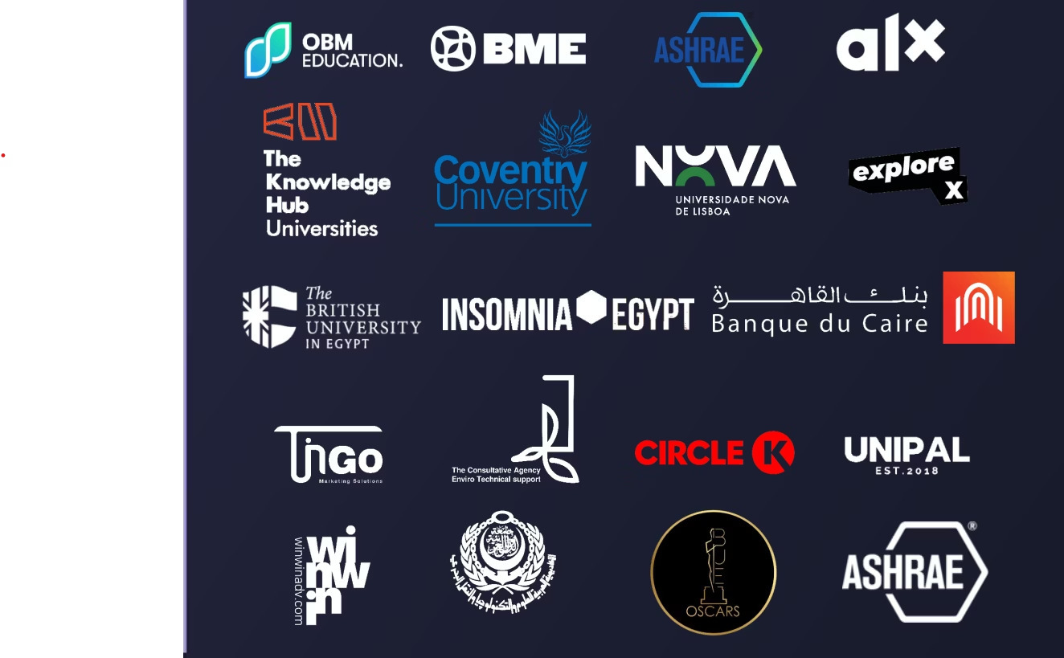

OUR

Clients

Enterprise Plan Highlights



Unlimited AI Interactions



Full API F Custom Integration Support



Dedicated Success Manager



Enterprise Analytics F SLA



Custom AI Model Development

**Request Enterprise Proposal** ³

# Join Our Upcoming Event

Experience the future of AI automation with SolvIt AI. Network with industry leaders, explore live demos, and unlock exclusive insights.

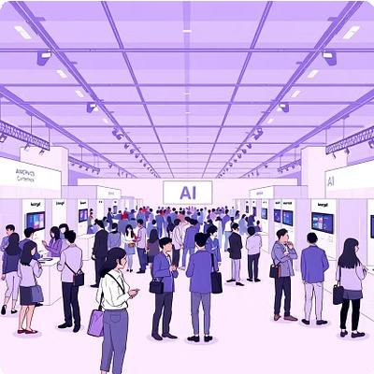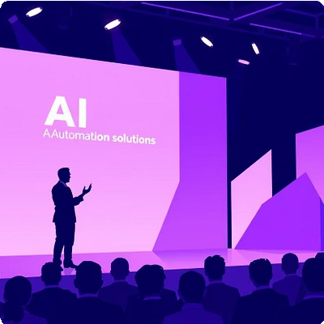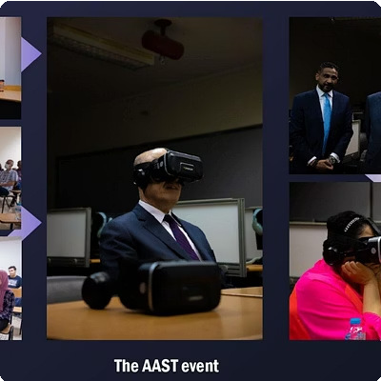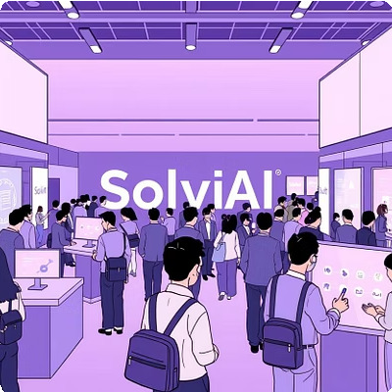[](https://gamma.app/?utm_source=made-with-gamma)



# Success Stories: Real Impact with SolvIt AI

Discover how our intelligent automation solutions have transformed enterprises across industries, driving efficiency, accuracy, and growth.

### Our clients experience:

Up to 60% reduction in manual workloads

Faster turnaround times in HR, finance, and support Enhanced customer satisfaction with conversational AI

# About SolvIt AI

SolvIt AI is a global leader in intelligent automation, trusted by Fortune 500s to transform operations with secure, scalable, human- centric AI. Our PhD-led team merges cutting-edge research with real-world engineering to deliver solutions that drive ROI from day one.



Innovation First

Relentlessly advancing AI to solve complex challenges.

Customer-Centric

Solutions designed around your business goals.

 Security

Compliant with industry-leading data protection standards.

Scalability

Flexible architectures grow with your enterprise.

# Ready to Automate Your Future?

' +20 1503885386 | / Solv[eitaiii@gmail.com](mailto:eitaiii@gmail.com)

Business Hours: Sun–Thu, 9AM–6PM EET | 24/7 Support Available

### Schedule Your Free AI Consultation

Transform Your Business with AI ³ Contact Us